This reading further elaborates on the meaning of qualitative versus quantitative.
As you have learned, there are two types of data: qualitative and quantitative.
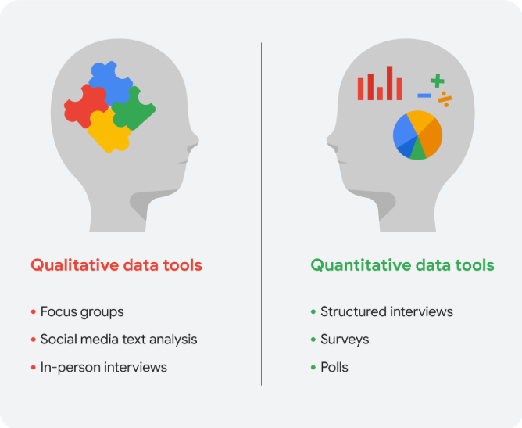

The beauty of dashboards
The following table summarizes the benefits of using a dashboard for both data analysts and their stakeholders.
Benefits | For data analysts | For stakeholders
Centralization | Share a single source of data with all stakeholders | Work with a comprehensive view of data, initiatives, objectives, projects, processes, and more
Visualization | Show and update live, incoming data in real time* | Spot changing trends and patterns more quickly
Insightfulness | Pull relevant information from different datasets | Understand the story behind the numbers to keep track of goals and make data-driven decisions
Customization | Create custom views dedicated to a specific person, project, or presentation of the data | Drill down to more specific areas of specialized interest or concern
It’s important to remember that changed data is pulled into dashboards automatically only if the data structure is the same. If the data structure changes, you have to update the dashboard design before the data can update live.

Whether you work with big or small data, you can use it to help stakeholders improve business processes, answer questions, create new products, and much more. But there are certain challenges and benefits that come with big data and the following table explores the differences between big and small data.
Small data | Big data
Describes a dataset made up of specific metrics over a short, well-defined time period | Describes large, less-specific datasets that cover a long time period
Usually organized and analyzed in spreadsheets | Usually kept in a database and queried
Likely to be used by small and midsize businesses | Likely to be used by large organizations
Simple to collect, store, manage, sort, and visually represent | Takes a lot of effort to collect, store, manage, sort, and visually represent
Usually already a manageable size for analysis | Usually needs to be broken into smaller pieces in order to be organized and analyzed effectively for decision-making
Challenges and benefits
Here are some challenges you might face when working with big data:
- A lot of organizations deal with data overload and way too much unimportant or irrelevant information.
- Important data can be hidden deep down with all of the non-important data, which makes it harder to find and use. This can lead to slower and more inefficient decision-making time frames.
- The data you need isn’t always easily accessible.
- Current technology tools and solutions still struggle to provide measurable and reportable data. This can lead to unfair algorithmic bias.
- There are gaps in many big data business solutions.
Now for the good news! Here are some benefits that come with big data:
- When large amounts of data can be stored and analyzed, it can help companies identify more efficient ways of doing business and save a lot of time and money.
- Big data helps organizations spot the trends of customer buying patterns and satisfaction levels, which can help them create new products and solutions that will make customers happy.
- By analyzing big data, businesses get a much better understanding of current market conditions, which can help them stay ahead of the competition.
- As in our earlier social media example, big data helps companies keep track of their online presence—especially feedback, both good and bad, from customers. This gives them the information they need to improve and protect their brand.
The three (or four) V words for big data
When thinking about the benefits and challenges of big data, it helps to think about the three Vs: volume, variety, and velocity. Volume describes the amount of data. Variety describes the different kinds of data. Velocity describes how fast the data can be processed. Some data analysts also consider a fourth V: veracity. Veracity refers to the quality and reliability of the data. These are all important considerations related to processing huge, complex datasets.
Volume | Variety | Velocity | Veracity
The amount of data | The different kinds of data | How fast the data can be processed | The quality and reliability of the data

